**[Hash Table](http://en.wikipedia.org/wiki/Hash_table" \t "_blank):** An array that stores pointers to records corresponding to a given data e.g (phone number). Simple word hash table is array of structure or pointer which used hashfuntion to find suitable pointers / structure to store data on it.

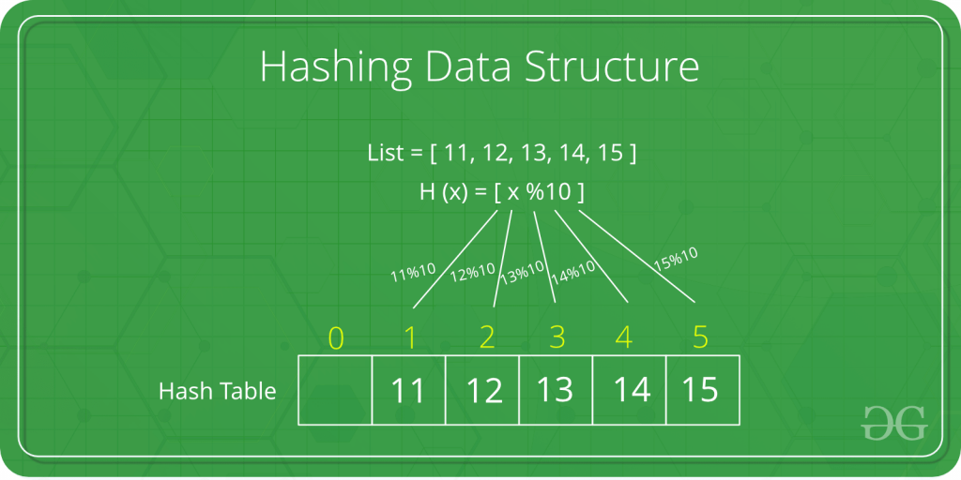

Hashing Data Structure

Hashing is an important Data Structure which is designed to use a special function called the Hash function which is used to map a given value with a particular key for faster access of elements. The efficiency of mapping depends of the efficiency of the hash function used.

Index Mapping (or Trivial Hashing) with negatives allowed

# Python3 program to implement direct index mapping with negative values allowed.

# Searching if X is Present in the given array or not.

def search(X):

    if X >= 0:

        if has[X][0] == 1:

            return True

        else:

            return False

    # if X is negative take the absolute value of X.

    X = abs(X)

    if has[X][1] == 1:

        return True

    return False

def insert(a, n):

    for i in range(0, n):

        if a[i] >= 0:

            has[a[i]][0] = 1

        else:

            has[abs(a[i])][1] = 1

# Driver code

if \_\_name\_\_ == "\_\_main\_\_":

    a = [-1, 9, -5, -8, -5, -2]

    n = len(a)

    MAX = 1000

    # Since array is global, it is initialized as 0.

    has = [[0 for i in range(2)]

              for j in range(MAX + 1)]

    insert(a, n)

    X = -5

    if search(X) == True:

        print("Present")

    else:

        print("Not Present")